Chapter 14, Solution 55.

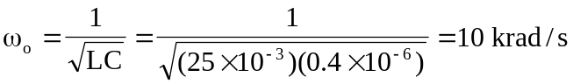
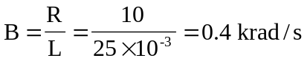

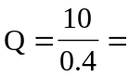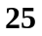

or 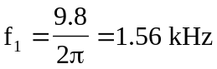
or 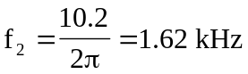

Therefore,
